Selection Sort output:
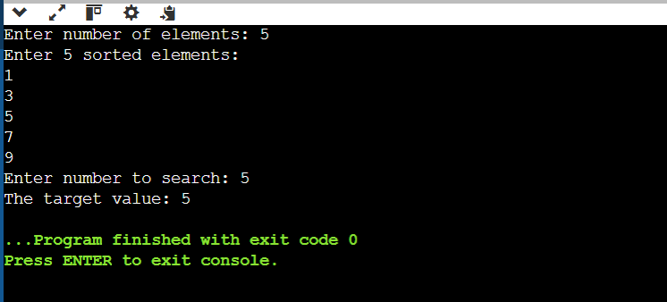

Bubble Sort Output:
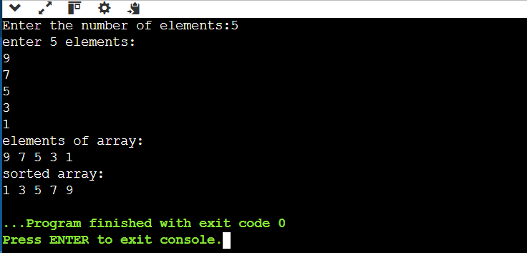

Insertion Sort Output:
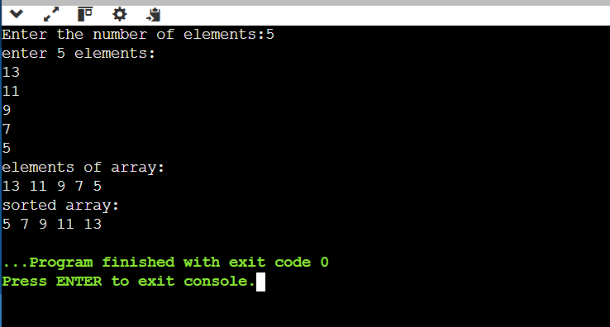

Merge Sort Output:
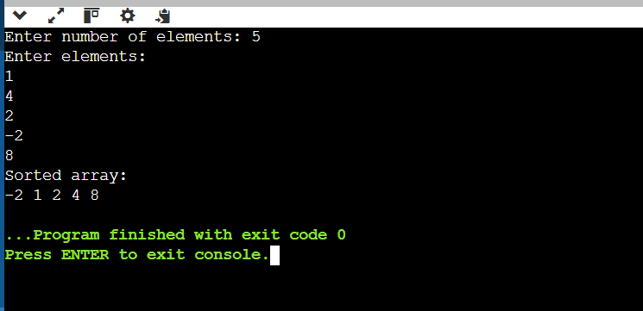

Quick Sort Output:
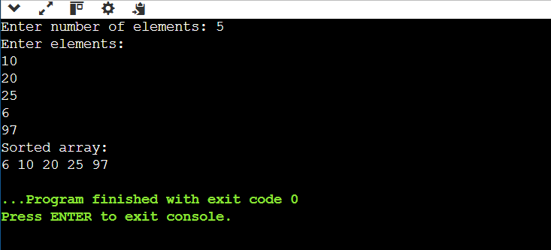

Time complexities of the sorting algorithms
Sorting Algorithm | Best Case | Average Case | Worst Case
Bubble Sort | O(n) | O(n²) | O(n²)
Insertion Sort | O(n) | O(n²) | O(n²)
Selection Sort | O(n²) | O(n²) | O(n²)
Quick Sort | O(n log n) | O(n log n) | O(n²)
Merge Sort | O(n log n) | O(n log n) | O(n log n)

